**WONG Wucius 王無邪 (1936 -)**

Wucius Wong is a Hong Kong artist famous for his integration of grids and Chinese landscape painting. Born in China, Wong moved to Hong Kong at the age of five and gained exposure to Western culture through receiving a bilingual education there. He is a member of the second generation of twentieth-century Chinese modernist artists and was a prominent member of the Hong Kong New Ink Painting Artists in the 1960s. Wong was influenced by the monumental landscape paintings of the Northern Song Dynasty of China (960-1127) and the systematic application of geometric forms found in Bauhaus design. Wong uses the texture stroke of Chinese ink paintings to draw the landscape and presents it in fragments within a grid structure. The grid is presented either as the frame structure of the painting, the outlines of rocks or the gaps between mountain ranges. Wong also puts great effort into exploring new techniques in the use of brush and ink. Wong has participated in numerous art exhibitions and his works are collected by collectors and museums worldwide. His artistic career spans over five decades and he is also a design and fine art educator, having written many books on related topics.

A self-taught artist in various Western art styles, in 1958, Wong became Lui Shou-kwan’s (呂壽琨 1919-1975) student, from whom he gained basic training in Chinese ink painting. In 1960, he received a scholarship to study fine art at the Columbus College of Art and Design in Ohio. Here, Wong struggled to establish his cultural identity, believing that Chinese ink painting, as associated with Chinese identity, was different from Western media. Wong returned to Hong Kong in 1965, and between 1974 and 1986, he taught in Hong Kong Polytechnic’s School of Design, while painting in his spare time. Believing that traditional Chinese landscapes lacked an ordered structure through which subjects could be arranged in a rational manner, Wong thus decided to use the geometric forms found in Western design to modernize the structure of Chinese landscape painting. Since 1978, grids and landscapes have been consistent subjects in his paintings. While twentieth-century Chinese artists modernized Chinese art by integrating it with Western modernism, many artists chose to harmonize the differences between these artistic styles. Wong’s art is significant because he chose to retain these conflicts.

Wong immigrated to the United States in 1984, but moved back to Hong Kong in 1996. Cityscapes became the new subject of his paintings, but he retained the grid theme. In the 2000s, Wong focused on exploring new brush and ink techniques and his paintings became more abstract.

**References and further reading**

http://wuciuswong.com/

Au-Yeung, Hin Henry (2003), *Design, Landscape and Modernity: Wucius Wong and the Development of Modern Hong Kong Art*,California: University of California, Santa Barbara

.

Ma, Wing Man Karen (2011) ‘The Comparison of the Swiss Grid and Wucius Wong’s Paintings: The Formation of Visual Features and Content’in *Appropriateness in Design*, M Phil in Visual Studies, Lingnan University, Hong Kong.

Sturman, Peter (2006) ‘Grids, Ground Planes, Fragments and Fractures: Modernism and the Chinese Landscape’ in *At the East-West Crossroads - The Art of Wucius Wong*, Hong Kong: The Leisure and Cultural Services Department.

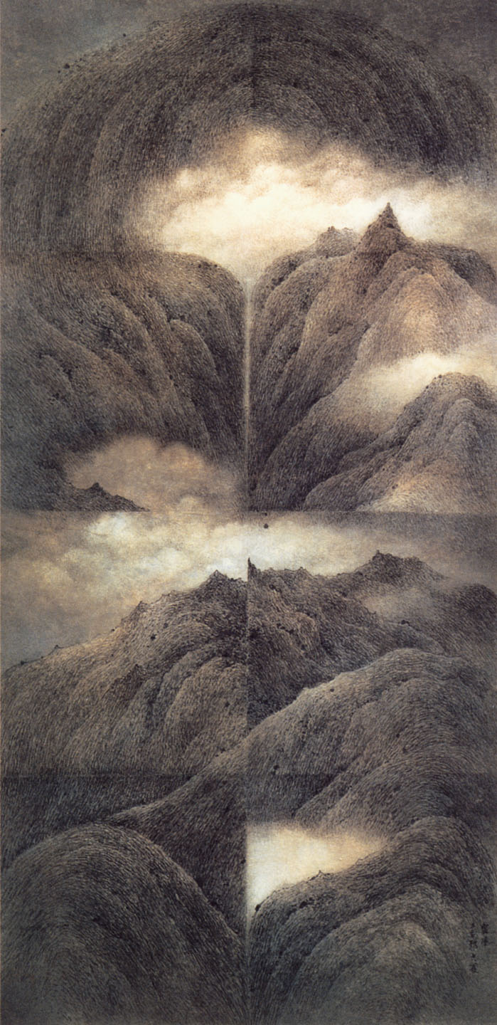

Wucius Wong, Cloud Harmony No. 1, 1978, Ink and color on paper, 136 x 67 cm, Collection of the Hong Kong Museum of Art.